The Effectiveness of Using Motion Capture and Pose-to-Pose Techniques in Animating Bengkulu Traditional Dance

Andang Wijanarko¹, Mochammad Yusa², Muhammad Pratama Hidayatullah³
¹ Information Systems, University of Bengkulu
^{2,3} Informatics, University of Bengkulu

Article Info |  | ABSTRACT
Article history:  Received Nov 12th, 2023  Revised Des 20th, 2023  Accepted Des 22th, 2023 |  | Animation techniques are evolving in accordance with the times. Motion capture is one of the most popular animation techniques today. The motion capture method has a number of drawbacks. Problems with bodily mobility, in particular, that are not captured on video. We studied how to use the pose-to-pose technique to solve movement issues in motion capture techniques, as well as how motion capture can produce complexly animated movements, such as those found in traditional Bengkulu dance movements. The research design follows a methodical approach to media production, beginning with pre-production and ending with post-production. Many traditional Bengkulu dance movements in animated videos that only used motion capture techniques did not match the original movements, particularly those of the wrists, fingers, thighs, and knees, according to the results of a twenty-person experiment. On the other hand, respondents believe that animated videos using motion capture and pose-to-pose techniques are the same as the original movements. This means that motion capture and pose-to-pose techniques work better for creating traditional Bengkulu dance movements.
Keyword:
Motion Capture
Pose-to-Pose
Bengkulu Traditional Dance

Corresponding Author:
Andang Wijanarko
Department of Information Systems
University of Bengkulu
WR. Supratman Street Kandang Limun Bengkulu
Email: andang@unib.ac.id

- INTRODUCTION
Currently, animation is a popular medium in society. This media is widely used in various fields such as education, health, tourism and entertainment. Animation media is typically used to interestingly communicate ideas to viewers [1]. As a result, your intended message is understood by the audience faster. Therefore, its use has become very widespread in various fields.
The methods for creating animation are evolving together with the times. One of the animation techniques that is widely used today is motion capture. Using motion capture techniques makes the process of creating movement in 3D animation much easier [2]. According to linked research, motion capture is chosen above other methods for creating 3D animation due to its higher accuracy. Aside from that, using a motion capture video to create animation is now simple. For self-produced and developed animations, this ease of use can save expenses and time [3].
There are also limitations in using motion capture techniques in making animations. Based on research by Ottosson and Schiillerqvist (2022), it was concluded that motion capture has shortcomings in creating repetitive movements. Especially in some hand movements and some movements that have deep perception [4]. Further research by Rantung, Sompie, and Sengkey (2021) came to the conclusion that while the motion capture technique is excellent for creating animations, there are issues with some of the more complex movements that are produced and it is unable to include head and finger movements in the animation, particularly issues with bodily mobility that are not captured on video [5].
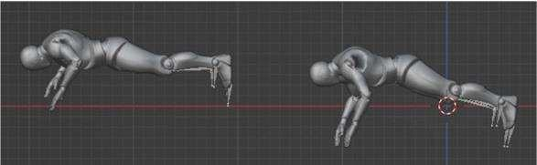
Figure 1. The problem with motion capture during a push-up is that the character's wrist is not perfectly aligned, causing them to unexpectedly sink past the X axis.

It is clear from the explanation above that there are a number of drawbacks to the motion capture method. Thus, this study investigates the potential of motion capture methods for intricate movements, specifically traditional Bengkulu dance, and identifies solutions for motion capture technique issues.
During the animation process, we propose a combination between the motion capture technique and the pose to pose technique to address the movement issues that arose from it. The pose-to-pose technique is selected due to its benefit: in the event that an animator discovers a pose error during the animation process, they can quickly locate the error and adjust the pose to ensure smooth animation [6].
In considering the problems mentioned above, we looked into how to apply the pose-to-pose principle to solve motion capture techniques' movement issues and demonstrate how motion capture can produce intricately animated movements, such as those found in traditional Bengkulu dance movements. Lastly, we use user testing mechanisms to investigate the effectiveness of motion capture and pose-to-pose techniques in producing complex movements.

- RESEARCH METHOD
The research design takes a methodical approach to media production, starting with pre-production, production, and culminating in post-production [7]. In the end, user testing of the successfully produced media determines how effectively motion capture and pose-to-pose techniques work to create traditional Bengkulu dance animations.

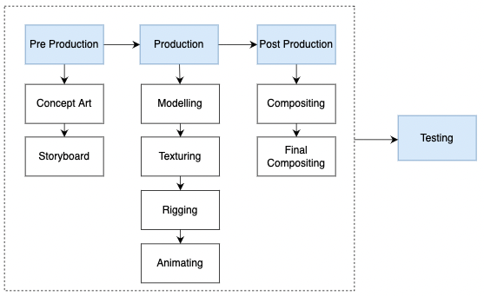
Figure 2. Research design

  - Pre-Production
The pre-production phase begins with ideation of the story, concept art creation, and storyboard creation to illustrate the animation's outcome [7]. We also searched for references in books and research journals, among other sources, to obtain a basic idea for the animated Bengkulu traditional dance.
The main idea in this research is to animate traditional Bengkulu dance based on 3D animation. The dance is a Bengkulu regional dance that is used to welcome and pay respects to guests [8]. The dance is danced by an odd number of female dancers, without a limit on the number of dancers.
In Bengkulu culture, the dance movements come from dance movements representing four regions in Bengkulu Province, namely Bengkulu City, North Bengkulu Regency, South Bengkulu Regency, and Rejang Lebong Regency. Following that, materials were gathered to create a 3D animation of a traditional Bengkulu dance. Character designs with Bengkulu traditional clothes, Cerando, Bengkulu traditional houses are a few examples. In addition, original footage of traditional Bengkulu dance moves recorded from a student in Bengkulu's dance studios is required as raw data for motion capture processing.

  - Production
The next stage is the production stage including modeling, texturing, rigging and animating [9]. At this stage the process carried out is starting from creating a 3D character model, and giving movement to the character model. Creating a character in three dimensions based on Concept Art references from earlier stages is what needs to be done during the modeling and texturing phase. In addition, Blender software is used for texturing, modeling, rigging, and also animating.
An animating process is required in order for the characters to move. Motion capture and pose-to-pose techniques are used in this case. The motion capture process is carried out with the help of the plask.ai application. The previous stage's Bengkulu traditional dance video was uploaded to the plask.ai application and converted to motion. Following that, the principle of pose-to-pose animation is used to overcome problematic movements in motion capture techniques, resulting in more realistic animated movements.

  - Post-Production
Compositing and final compositing are post-production stages [7]. The process carried out at the compositing stage includes adding effects such as shadow, light, and properties that were prepared at the concept art stage. The animation is then rendered to proceed to the final stage. Following that, the final compositing process involves combining all animation components, including the animated video itself, background sound, and some text. Adobe Premiere Pro software is used for the final compositing stage.

  - Testing
The final stage of this research is to put the animated video to the test. This stage aims to assess the effectiveness of motion capture and pose-to-pose techniques in animating difficult movements in traditional Bengkulu dance.
The testing instrument is a questionnaire with Guttman scale measurements. The Guttman scale, also known as a scalogram scale, is excellent for ensuring research results concerning the attitudes or traits being studied. Furthermore, the value 1 is used for “Yes” and 0 is used for “No” when calculating question scoring [10]. Questionnaires were distributed to twenty students from Senior High School number 7 in Bengkulu City, particularly those who participated in dance extracurricular activities. Respondents were asked to watch animated videos that used motion capture and pose-to-pose techniques, as well as animated videos that did not use pose-to-pose techniques. To obtain the results of percentage-based calculations, use the following formula:

$\frac{Score}{Number of Respondents} x 100\%$ (1)

In this study, the animation movements were evaluated and compared by determining whether the movements of the body parts corresponded to the original movements of traditional Bengkulu dance. Movements of the neck and head, eyes, shoulders, wrists, elbows, fingers, thighs, knees, and ankles are among the body parts that perform dance movements. These elements were examined and compared between motion capture-only animation and motion capture-and-pose-to-pose animation. If the movement matches, it is checked; otherwise, it is left blank.

- RESULTS AND DISCUSSIONS
  - Pre-Production
The main part of the pre-production stage is generating concept art and storyboards. Figure 3 shows the concept art used to create the animation in this study. There is a photograph of a dancer dressed in traditional Bengkulu attire. Other properties, such as traditional houses and cerano, are frequently used in traditional events in Bengkulu. The concept art is used as a reference for creating 3D objects in this research.
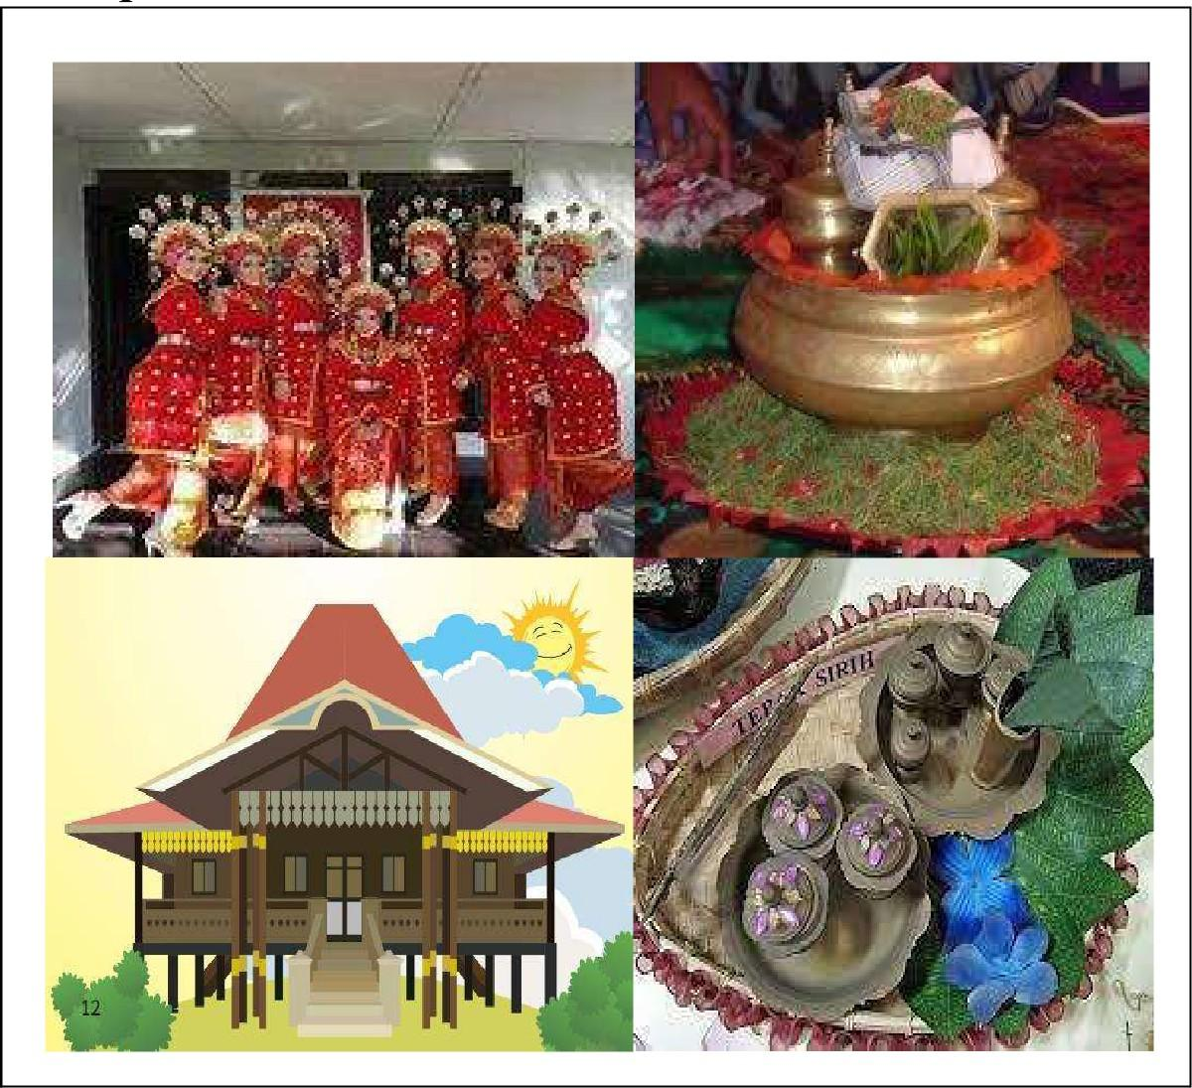
Figure 3. Concept Art

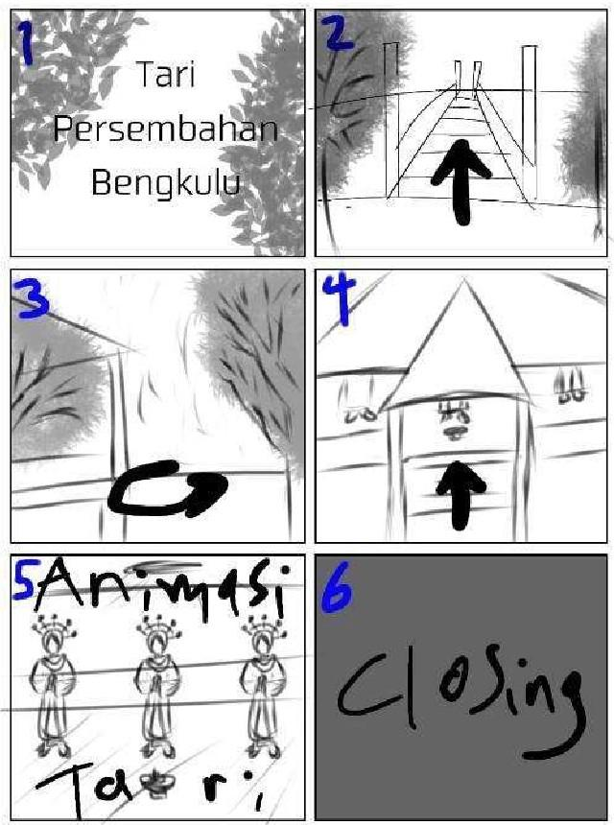
Following the creation of concept art, the next stage is the creation of a storyboard. Storyboards are used to visualize ideas in order to accelerate up and simplify the animation creation process.
Figure 4. Storyboard

  - Production
Modeling is the first step in the production process. Blender software was used for the modeling process. This process results in the modeling of the characters and properties mentioned during the concept art creation stage. The modeling process makes use of several Blender software features, including plane, circle, cube, and grid. In addition, the edit mode and sculpt mode features were used to customize the models created.

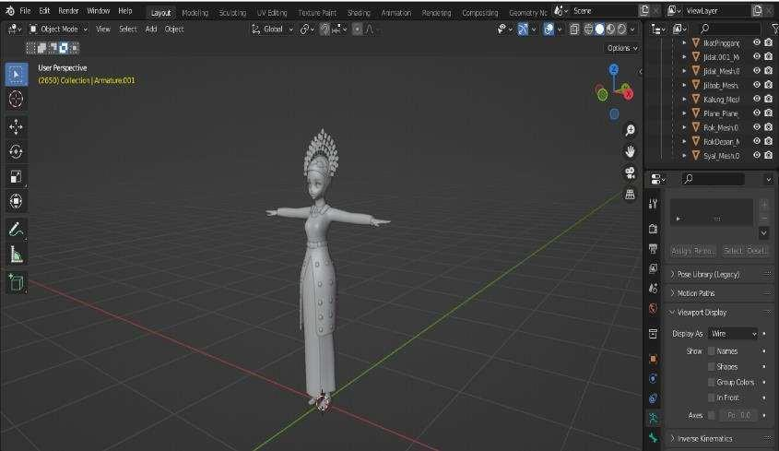
Figure 5. Character Modeling

The texturing process begins after the 3D objects have been created. 3D assets are coloured and shaded during the texturing process.

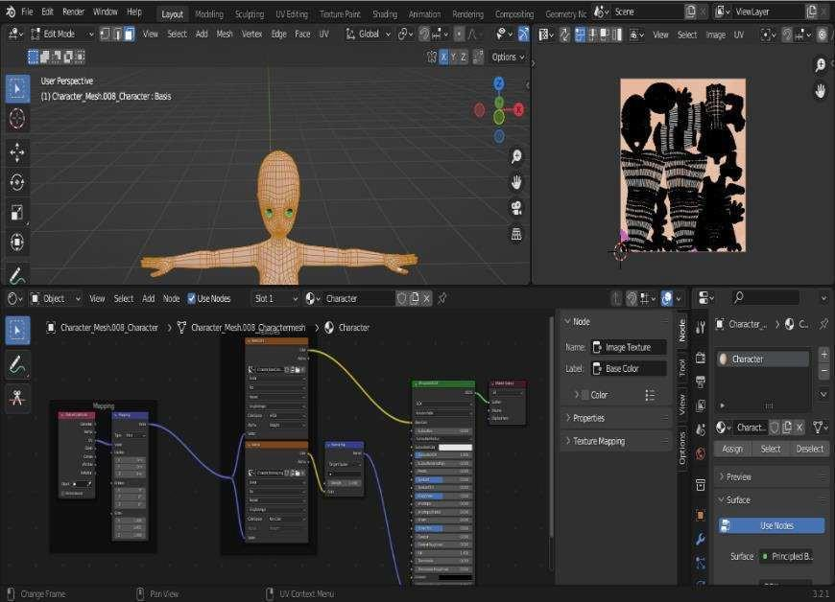
Figure 6. Texturing Process

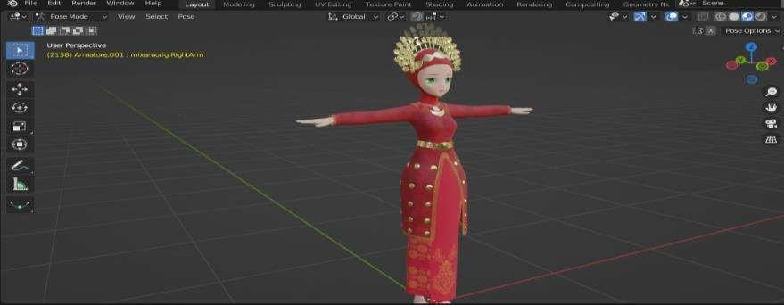
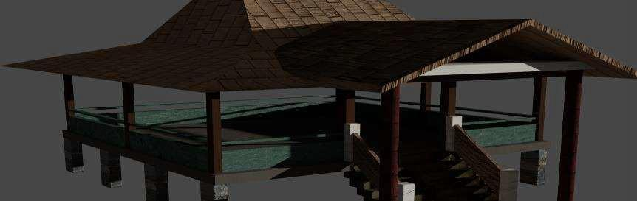
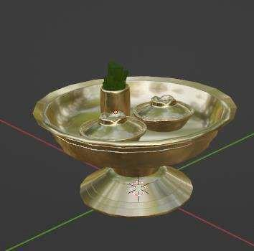

Figure 7. The results of modeling and texturing process

Animating the object is the final step in the production process. Characters are given bones (rigging) to allow them to move. Following that, the motion capture and pose-to-pose techniques used to move the object. Objects are still animated using Blender software, which includes features like Armatures, Constraints, and Object Modifiers.

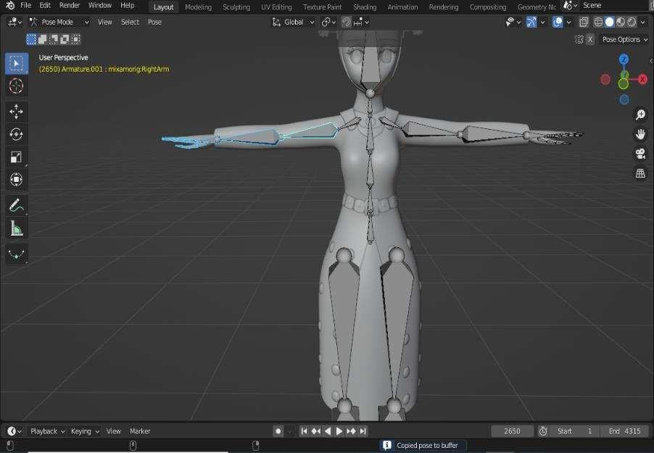
Figure 8. Rigging process

After the rigging is completed, the characters will be given traditional Bengkulu dance movements. Motion capture techniques are fully utilized to move the characters in this section. We prepared a video recording of one of the dance studio students in Bengkulu performing traditional Bengkulu dance movements during the pre-production process. The video is uploaded to the plask.ai web application, which extracts the dance movements in .fbx format.
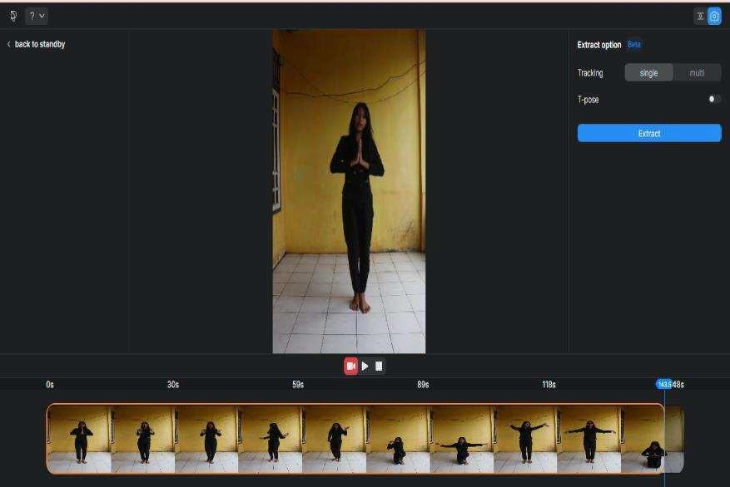
Figure 9. Motion capture process using plask.ai

In the previous step, the motion capture file was imported into the Blender software. Following that, we examined any movements that did not correspond to the original movements of traditional Bengkulu dance. To overcome the problem of inappropriate movements, the pose-to-pose technique must be used. For example, there are some finger movements that we believe are inconsistent with the original Bengkulu traditional dance movements. As a result, we removed several key frames from the inappropriate movements and rearranged them in accordance with the original dance movements. Aside from the examples given above, we also assessed movements in the neck and head, eyes, shoulders, wrists, elbows, fingers, thighs, knees, and ankles. The pose-to-pose technique was used to revise parts of the dance that were not in accordance with the original Bengkulu traditional dance movements.

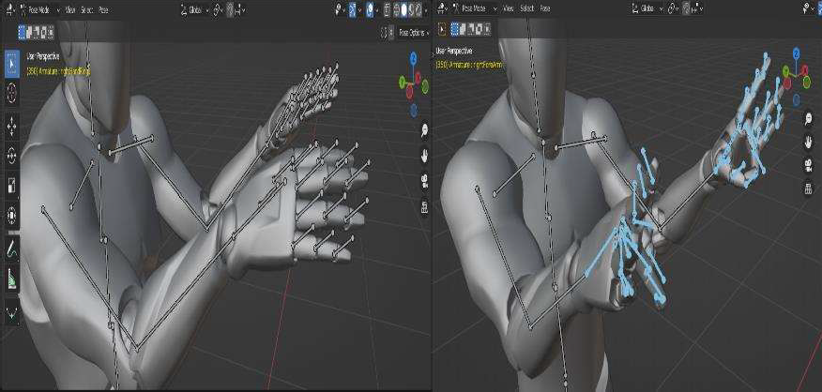
Figure 10. Finger movements before and after applying the pose-to-pose technique

After all of the dance movements have been approved, use the retargeting method in Blender software to pair the 3D characters with motion capture movements.

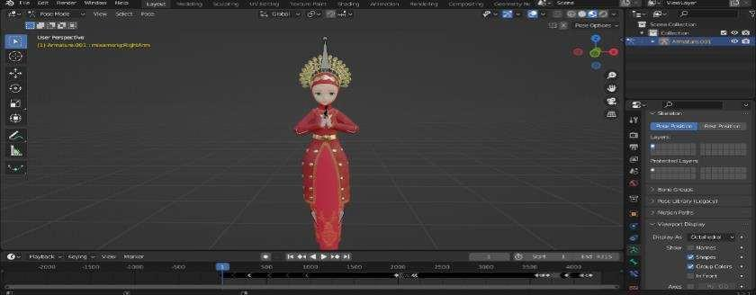
Figure 11. Retargeting results

  - Post-Production
Before beginning the rendering process, a compositing process is carried out, which involves combining all 3D objects and properties created during the production stage. Aside from that, adjusments were made to the camera and lighting to make the video display more appealing. The compositing process concludes with the rendering process in Blender software.

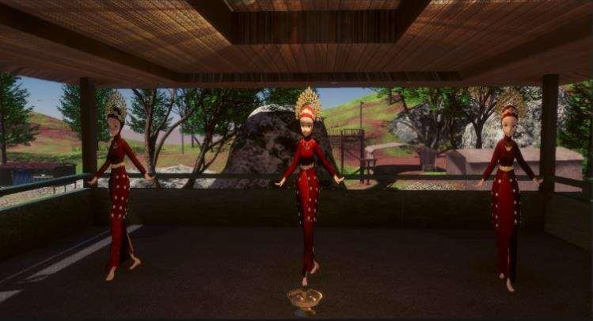
Figure 11. Rendering results

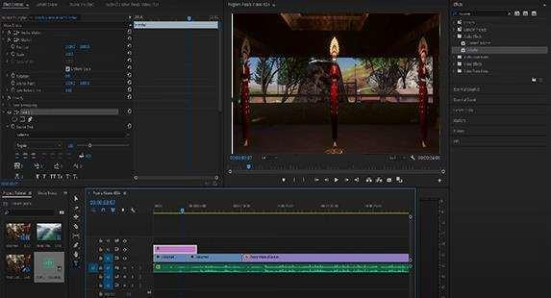
Finally, the final compositing process is completed in post-production using Adobe Premiere Pro software. The previous process's rendered Bengkulu traditional dance animation video is combined with several elements such as text and back sound.
Figure 12. Final compositing processes

  - Testing
The testing stage was carried out to find out if the motion capture and pose-to-pose techniques used in this research could produce traditional dance animation movements that were identical or similar to the original dance movements. Therefore, we created two Bengkulu traditional dance animation videos, the first of which uses motion capture and pose-to-pose techniques, and the second of which uses only pose-to-pose techniques.
Twenty high school students from high school number 7 of Bengkulu City participated. Respondents were chosen from students who participated in dance extracurriculars and had performed traditional Bengkulu dances based on the case study in this study. Respondents were asked to watch two videos, one video was using motion capture and pose-to-pose techniques and the other one was using only motion capture techniques. Following that, respondents were given a validation sheet after watching the two videos to assess whether the two videos matched the original movements, particularly in the neck and head, eyes, shoulders, wrists, elbows, fingers, thighs, knees, and ankles. Subsequently, respondents must check the validation sheet if the movements in the body part are appropriate. If there is an inappropriate movement, the respondent simply does not need to check.

Table 1. The results of assessment of Bengkulu traditional dance animation videos
The Movement | Motion Capture Only | Motion Capture and  Pose-to-Pose
Neck and head | 20 | 20
Eyes | 0 | 20
Shoulders | 20 | 20
Wrists | 0 | 20
Elbows | 20 | 20
Fingers | 0 | 20
Thighs | 6 | 20
Knees | 13 | 20
Ankles | 20 | 20

The results from table 1 are then visualized using formula 1 using a bar graph to further comprehend the comparison results of the tests performed.

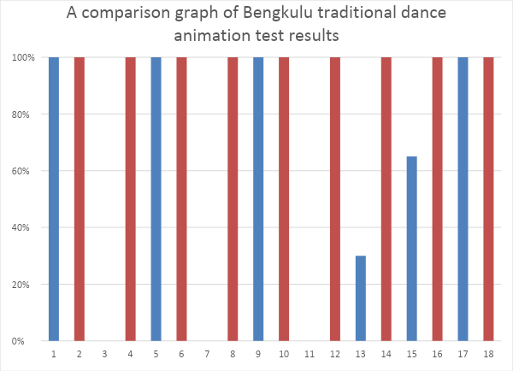
Figure 13. A comparison graph of Bengkulu traditional dance animation test results

Figure 13 shows that animated videos of traditional Bengkulu dances using motion capture techniques yield mixed results. Only movements of the neck and head, shoulders, elbows, and ankles receive a perfect score. Meanwhile, other movements such as knee, thigh, eye, and wrist, were considered inconsistent by the respondents with the original movements. On the other hand, animated videos that use motion capture and pose-to-pose techniques, receive perfect scores. This means that all of the respondents thought the video matched the original movements of traditional Bengkulu dance.
According to Figure 13, Bengkulu traditional dance videos that use motion capture and pose-to-pose techniques can overcome problematic dance movements better than just motion capture techniques. Especially for movements with tiny details such as the eyes, wrists, and fingers. Another example is the movement of the thighs and knees in motion capture-only animated videos. When the animated character sits and kneels, the motion capture technique cannot capture these movements because they are covered by the body and hands; however, pose-to-pose can solve this problem.
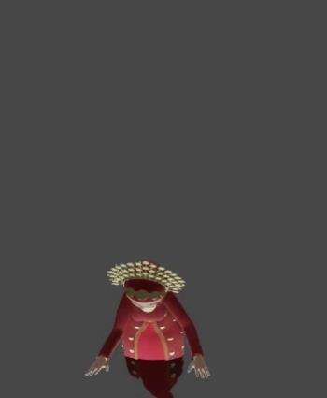
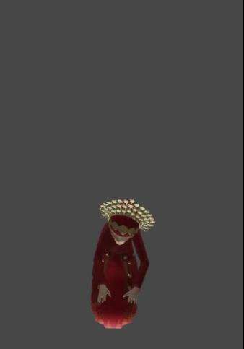
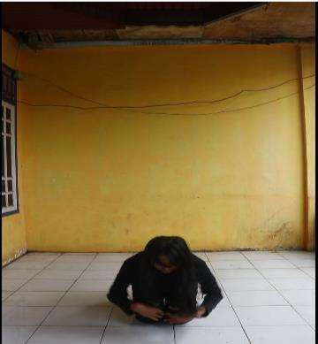

Figure 14. Comparison of Bengkulu traditional dance animation movements in kneeling movements (from left to right: motion capture only, motion capture and pose-to-pose, and real)

- CONCLUSION
The Bengkulu traditional dance animation video was created successfully through pre-production, production, and post-production processes. Motion capture and pose-to-pose animation techniques are used to animate traditional Bengkulu dance movements. Following that, Bengkulu traditional dance animation videos with motion capture and pose-to-pose techniques, as well as animated videos without pose-to-pose techniques, were tested on respondents to see if there were any similarities to the original movements. The results of an experiment of twenty people revealed that many traditional Bengkulu dance movements in animated videos that only used motion capture techniques did not match the original movements, particularly those of the wrists, fingers, thighs, and knees. Respondents, on the other hand, rate animated videos that use motion capture and pose-to-pose techniques as being the same as the original movements. This means that motion capture and pose-to-pose techniques are more effective for creating traditional Bengkulu dance movements.
This study has several weaknesses that should be addressed in future research. One of them is the number of respondents in the animated video test, which was only twenty. More respondents will improve the test results in this study. Aside from that, there are shortcomings in the animated character designs, particularly in the Bengkulu traditional clothing accessories. This research is limited by the manufacturing process, which is complicated and time consuming. Finally, future research should be able to compare various motion capture applications to determine which one is best in exporting animated movements.

REFERENCES

[1] Y. K. Ramadhan and A. A. Suripatty, “Pembuatan Video Animasi Sebagai Media Promosi Jasa Agen Bni 46 Dengan Menggunakan Adobe Animate Dan Adobe Premiere Pro,” Citizen : Jurnal Ilmiah Multidisiplin Indonesia, vol. 2, no. 1, pp. 11–16, 2022, doi: 10.53866/JIMI.V2I1.24.
[2] J. Pratama and S. Artikel, “Design And Application Of Motion Capture On 3d Characters In Video,” JURNAL ILMIAH INFORMATIKA, vol. 10, no. 01, pp. 35–43, Mar. 2022, doi: 10.33884/JIF.V10I01.4613.
[3] S. K. Dirjen et al., “Implementation of Rotoscoping Technique in the making of the Hang Tuah Ksatria Melayu 3D Animated Film,” Jurnal RESTI (Rekayasa Sistem dan Teknologi Informasi), vol. 4, no. 5, pp. 943–950, Oct. 2020, doi: 10.29207/RESTI.V4I5.2404.
[4] J. Ottosson and Y. Schüllerqvist, “An Evaluation Of Markerless Motion Capture For Amateurs,” 2022. Accessed: Nov. 11, 2023. [Online]. Available: https://urn.kb.se/resolve?urn=urn:nbn:se:kth:diva-320283
[5] B. J. R. Rantung, S. R. U. A. Sompie, and R. Sengkey, “Penerapan Motion Capture Dalam Pembuatan Animasi 3D Gerakan Dasar Kempo,” Jurnal Teknik Elektro dan Komputer, vol. 10, no. 2, pp. 119–126, Jul. 2021, doi: 10.35793/JTEK.V10I2.33874.
[6] S. F. Salmon, V. Tulenan, and B. A. Sugiarso, “Penggunaan Metode Pose to Pose dalam Pembuatan Animasi 3D Tarian Minahasa Maengket,” Jurnal Teknik Informatika, vol. 12, no. 1, Oct. 2017, doi: 10.35793/JTI.12.1.2017.17867.
[7] R. A. Rashid, N. S. A. Mutalib, and D. H. A. Manan, “Development of 3D Animation on How to Fight Covid19,” International Journal of Business and Technology Management, Oct. 2022, doi: 10.55057/ijbtm.2022.4.3.17.
[8] D. D. Anggraini, H. Hasnawati, and N. Agusdinata, “PELATIHAN TARI PERSEMBAHAN BAGI GURU SDN 47 KOTA BENGKULU,” Batoboh: Jurnal Pengabdian Pada Masyarakat, vol. 3, no. 2, pp. 111–120, Sep. 2018, doi: 10.26887/BT.V3I2.523.
[9] D. Apriliyanti, J. N. Fadila, ; Fresy Nugroho, and I. Engineering, “3D ANIMATION DESIGN ‘SCIENCE, LANTERNS TO HEAVEN’ USING THE POSE-TO-POSE METHOD,” JITK (Jurnal Ilmu Pengetahuan dan Teknologi Komputer), vol. 8, no. 1, pp. 46–55, Aug. 2022, doi: 10.33480/JITK.V8I1.2231.
[10] B. Agustan, R. Rahman, and C. B. Panglungguh, “Analisis Efektivitas Pembelajaran Daring Terhadap Hasil Belajar PJOK Selama Pandemi Covid-19,” Physical Activity Journal (PAJU), vol. 4, no. 2, pp. 173–186, Apr. 2023, doi: 10.20884/1.PAJU.2023.4.2.6806.

